Name ______________________________ Date __________________________
Advanced Algebra Review

Chapter 5 Review
Question #1: Question #2:
Rewrite in log form. Evaluate the following expression.
$4^{2}=16$ $\log_{2}{1}$

Question #3: Question #4:
Rewrite in exponential form. Solve for x. Round to the nearest tenth.
$\log_{x}{92=5}$ $\log_{x}{92=5}$

Question #5: Question #6:
Condense and simplify. Rewrite in exponential form.
$2\log{5-\frac{1}{2}log{25}}$ $\log_{x}{z}=y$

Question #7: Question #8:
Expand. Which expression is equal to x?
$\log{\frac{\sqrt{a}}{bc}}$ a) ln e⁵ c) log x b) ln e^{x} d) x log 2

Question #9: Question #10:
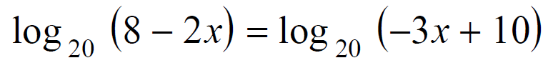
Solve the following for x. Solve for x.
$\log_{6}\left(x-8\right)=2$

Question #11: Question #12:
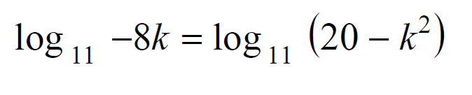
Solve for k. Check your solutions. Solve the equation and round to the hundredths place if necessary.
$e^{4x}=12$

Question #13: Question #14:
Solve for x. Solve for x.
$\log_{(x-1)}{4=\frac{1}{3}}$ $\log_{(x+4)}{(17x-4)=2}$

Question #14: Question #15:
Solve for x. Solve for x. Check your solutions.
$\ln{x^{2}}-\ln{5}=\ln{5}$ $\log_{2}{x}+\log_{2}\left(x+2\right)=3$

Question #16: Question #17:
Susie invests $500 in an account that The number of bacteria present in a Petri
is compounded continuously at an annual dish can be modeled by the function
interest rate of 5%, according to the formula $N=50e^{3t},$ when $N$ is the number of
$A = Pe^{rt}$. Approximately how many years bacteria present in the Petri dish
will it take for Susie’s money to double? after $t$ hours. Using this model,
determine, to the nearest hundredth, the
number of hours it will take for $N$ to reach
30,700?

